Make or use an online image to share a bible verse.
Turn it into a puzzle for a bit of lockdown fun.
Follow these steps to make an online version of your verse and then easily make it into an online puzzle. i
Or just send your image to Jo and she will transform it for you. Let her know what you want the pop up message to say when the puzzle is solved, ie., Hi, This is Fred from the morning service and I love this verse!
Email the details to Jo and look at for your verse in our daily puzzle challenge.

IF YOU ARE CREATING YOUR OWN IMAGE
- Create your bible verse image.
Use pen and paper to draw your own verse and image. Take a photo and save to your computer OR
Use your favourite online design tool and save to your computer.
TIP: Check out this great tutorial by YouVersion on how to make your own verse image to share on any social media. You will need to make a free account.

- Now you need to get your image from your computer and put it online. To do this go to the imgur website and add your image. This will give you an online address for your image. Hover over your uploaded image and you will see the link. Copy this link and save it somewhere as this is what we need to make the puzzle.
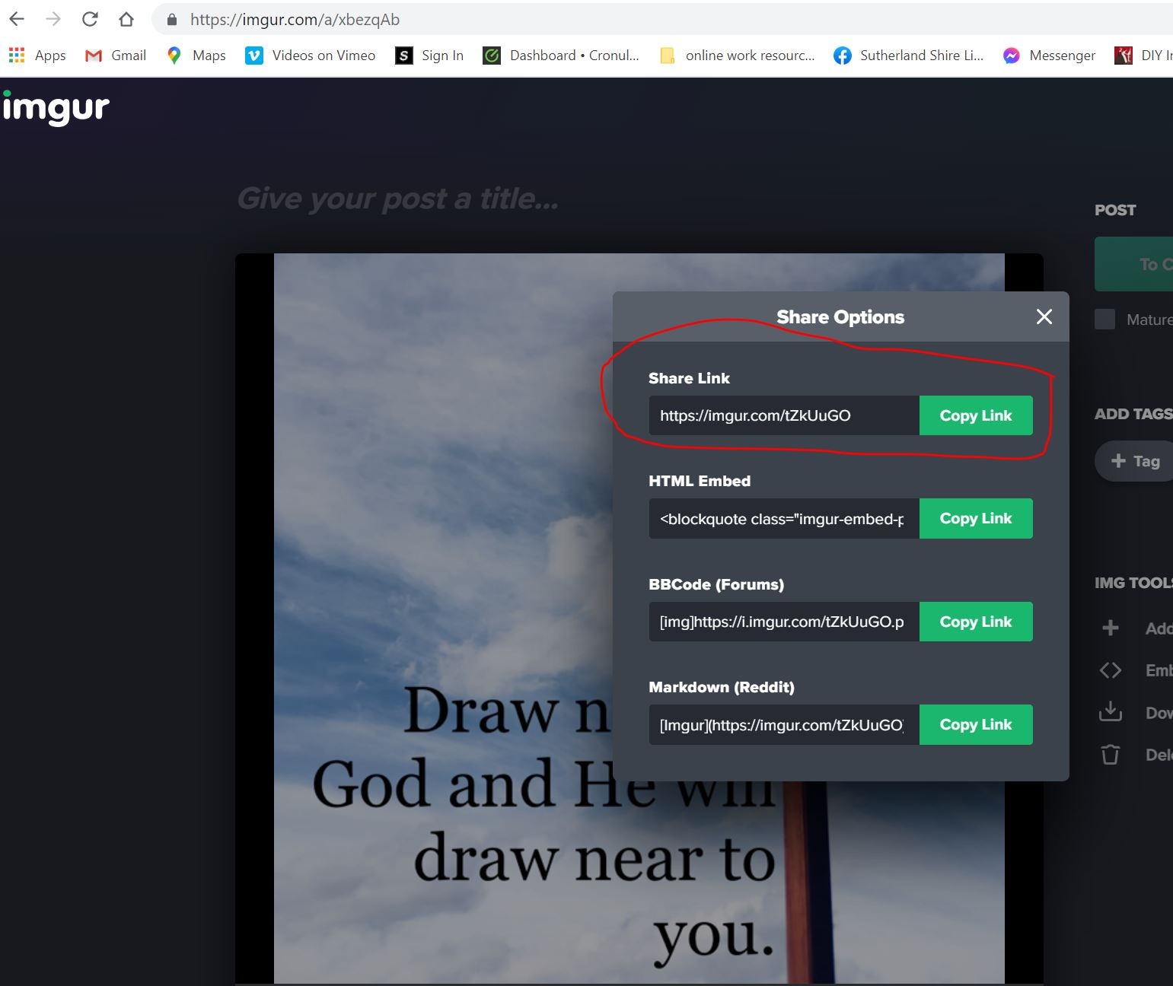

IF YOU WANT TO USE AN EXISTING ONLINE IMAGE
If you prefer to skip the above steps you can find an image online and copy the link. Use the three vertical dots to bring up the link that you need to copy.
In this example the verse is from BibleVerseImages.com

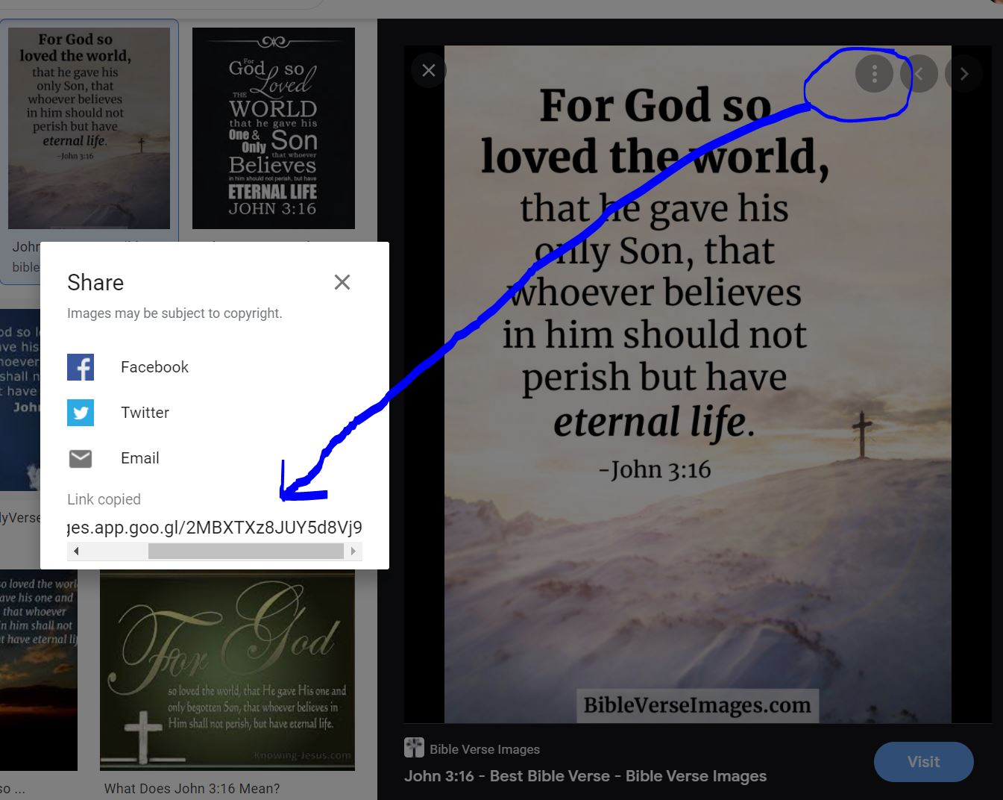

TO MAKE THE PUZZLE
Go to Jigsaw Explorer.
The picture below shows what you need to fill in to create your own puzzle.
Paste in the link to your image and add .jpg to the end of the link
Put your details in the credit line so we know whose favourite verse it is. Eg., Hi this is Fred from the morning service. This message will pop up when the puzzle is solved.
Set the number of pieces – that’s up to you.
Select Mystery Puzzle so that the preview photo is hidden.
Create the puzzle and copy/save the link.
Try it for yourself first and then email the link to Jo.

